Fenland Bowl I
Welcome Blood Bowl coaches. We are pleased to announce the first Fenland Bowl. Coaches and teams can now register for the first (hopefully of many) Fenland Bowls.
Fenland Bowl I will take place on Saturday 2nd November 2024 in Littleport and will consist of 3 games of Blood Bowl.
Tickets
Tickets are £12 each
Please make all payments via Paypal (Friends & family) to grax1912@yahoo.co.uk
Please remember to include your name, NAF name and NAF number with your payment.
We have a capacity for 24 coaches for the first Fenland Bowl however, if this is a success we will look to increase capacity for Fenland Bowl II.
Venue
The event will take place at the Littleport Scout & Guide Hut, address below

Littleport Scout & Guide Hut
Camel Road
Littleport
Ely
CB6 1PU

There is ample parking on site.

Hot drinks (Tea and coffee) will be available in the kitchen and included within your ticket price.

You will need to bring your own food, alternatively there is a Co-op, convenience store and some takeaways around a 2-minute drive from the venue.

What to bring

Your team, two copies of your roster (With extra skills clearly marked), rulebook & latest FAQ/Errata, templates and dice (Please note, following suit with other tournaments we are only allowing GW official Blood Bowl dice to be used, and of course NAF dice). Please can players also bring a pitch and dugouts so we can make sure we have enough pitches on the day.

Whilst painting is not a requirement but of course preferred, we ask positionals are clearly identifiable and the team is numbered.

Format

The tournament will be a three game tournament using Blood Bowl Season Two (BB 2020) Official Rules (as clarified by the most recent official FAQ). The first game will be randomly drawn between coaches with subsequent matchups following a Swiss - Resurrection style system.

Team Building

Starting team value will be 1.15 million gold pieces (Team Value 1150) and coaches may choose a legal roster up to this value.

Team tiering will be as per the latest GW FAQ/Errata.

Rosters may be chosen from any of the teams in the following:

Blood Bowl Rule Book
The official “Teams of Legend” pdf
Khorne, Norse, Amazon, Vampire and Gnomes from Spike magazines 13, 14, 15, 16 & 17 respectively.
Additional NAF Roster for Slann
Any additional official teams and rosters from Spike magazines released AT LEAST 2 WEEKS before the event will also be allowed

Skill Packages

Tier 1 Teams – 6 additional skills - No player may receive more than 1 additional skill - Either 6 primary skills or 5 primary and 1 secondary

Amazon, Chaos Dwarf, Dark Elf, Dwarf, High Elf, Lizardmen, Norse, Shambling Undead, Skaven, Underworld Denizens, Wood Elf

Tier 2 Teams - 8 additional skills - 1 player may receive 2 additional skills, the rest can only receive up to 1 additional skill - Select from 1 of the following 3 skill packages
(1) 8 primary skills
(2) 7 primary skills and 1 secondary skill
(3) 6 primary and 2 secondary skills

Black Orc, Chaos Chosen, Chaos Renegade, Elven Union, Human, Imperial Nobility, Khorne, Necromantic Horror, Nurgle, Old World Alliance, Orc, Slann, Tomb Kings, Vampires

Tier 3 Teams - 10 additional skills - 2 players may receive 2 additional skills, the rest can only receive up to 1 additional skill - Select from 1 of the following 3 skill packages

(1) 10 primary skills
(2) 9 primary skills and 1 secondary skill
(3) 8 primary and 2 secondary skills
(4) 7 primary and 3 secondary skills

Goblin, Halfling, Ogre, Snotling, Gnomes

Only chosen primary skills or chosen secondary skills may be selected, randomly chosen skills are not allowed. Characteristic increases are not allowed.

Inducements

We will start off with the big one. As this is the first Fenland Bowl, star players and especially mega stars have no interest in such an unknown competition. No amount of money can persuade them to join a team entering the first Fenland Bowl, but of course if the competition were to gain more attraction and fame, they would definitely reconsider their stance for future Fenland Bowls.

Star Players and Mega Stars are not allowed (Bar the Fenland Bowl I special star player, more on this later)

Any inducements from the list of “common inducements” on page 89 of the Blood Bowl rulebook can be taken, with the following changes:

Star Players and Mega Stars are not allowed (Bar the Fenland Bowl I special star player)
Wizards, Biased Referees, Mercenaries and Special Play card inducements are not allowed.
The following additional inducement rules from the “Death Zone” supplement are allowed:
(In)Famous Coaching Staff
Other Inducements from p36-39, excluding Medicinal Unguent and Side Bet.
Any additional inducements published in any official Spike magazine prior to the date of the event (excluding any from the excluded categories listed above e.g. Wizards).
A special mercenary ‘The Littleport Black Dog’ will be available for hire, more on this in the special rules section.

Fenland Bowl Special Rules

The Fens, or Fenland(s), are a naturally marshy region in eastern England. Therefore, to reflect this we will be replacing the usual weather table with the Graveyard Weather Table from the “Death Zone” supplement. Copies of this table will be provided on the day.

Another point of local history is the Ely and Littleport riots of 1816. At the time unemployment was high and costs of grain were rising. Fuelled by alcohol, a group of Littleport residents left the inn and began intimidating wealthier residents, demanding money and destroying property. The riots spread to Ely and were eventually quelled by a militia of citizens from Ely led by Sir Henry Bate Dudley. To reflect this, every time a touchdown is scored fans of the opposing team break onto the pitch! Choose a random player on scoring team (This can include players currently on the reserves bench, but not knocked out or players who have sustained a casualty). Once a player has been randomly selected, the opposing coach of the player selected rolls a D6 and consults the below table:

1 – No harm is done to the player
2-4 – The player is knocked out, but still rolls to see if they recover from the knock out during the current turn end of drive sequence
5-6 – The player is seriously knocked unconscious. The player is placed in the knock out section but does not roll to see if they recover during this turns end of drive sequence. They will roll as usual during following end of drive sequences after.

Finally, Littleport is home to two different legends of spectral black dogs. Teams can hire a special Star Player reflecting this spectral black dog for 75,000 gold pieces, also they will lose 1 of their primary skills within their teams tier skill package.
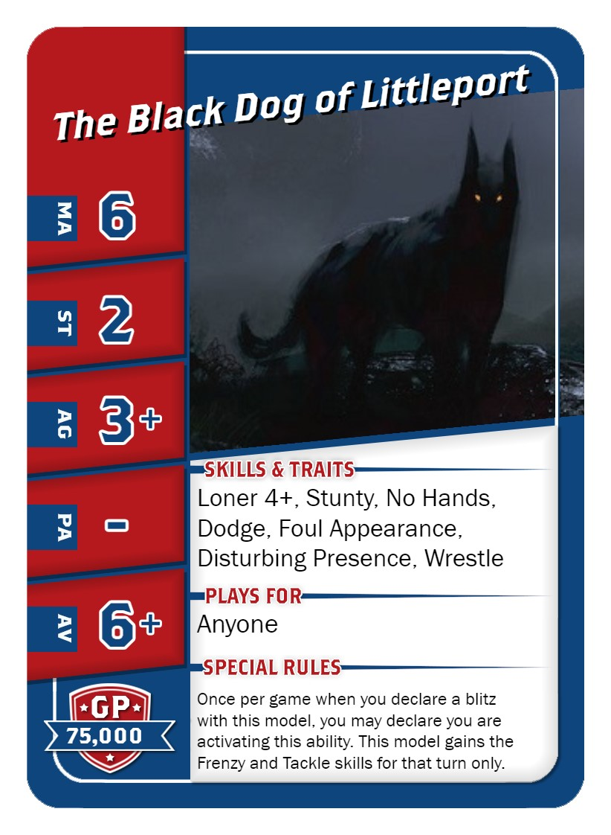

Scoring

The scoring system will be as follows:
Win = 30 points
Draw = 15 points
Loss = 0 points

Bonus points awards as follows:
Casualty caused (To a maximum of 3 bonus points per game)
Touchdowns Scored (To a maximum of 3 bonus points per game)
Clean sheet (No touchdowns conceded – 1 bonus point awarded for each game where you keep a clean sheet)

Tiebreakers will be Strength of Schedule, followed by Touchdown difference and then Casualties difference.

In terms of casualties all casualties you cause to your opponent count (including fouls and crowd surfing). Casualties caused to your opponent’s players as a result of failed dodges/rushes do not count.

Prizes

We are very pleased to announced that our Tournament is sponsored by the Ely Cycle Centre. Prizes will be awarded for the following:

Winner
Runner Up
3rd Place
Most Touchdowns
Most Casualties
Stunty Cup
Best Painted
Wooden Spoon

There is a maximum of 1 prize per person on the day, so if a player wins 2 or more awards, the ‘lesser’ trophy will go to the next eligible coach.

There will also be spot prizes available on the day.

Ely Cycle Centre are our main sponsor for prize support (Don’t worry they have a model store/section, the winner won’t be getting a bicycle!). Any small amount of money left over will be donated to the Littleport Scouts.

Schedule

Registration: 9:30 – 9:50
Tournament briefing and announcements: 9:50-10:00
Game 1: 10:00 – 12:15
Lunch: 12:15 – 13:00
Game 2: 13:00 – 15:15
Short break: 15:15 – 15:30
Game 3: 15:30 – 17:45
Awards ceremony and close: 18:00

Each round will be played within a strict time limit of 2 hours 15 minutes. Regular calls will be made for 1 hour remaining, 30 minutes remaining and 15 minutes remaining. If you are not into the second half when the 1 hour remaining call is made, we would encourage you to start a chess clock with around 2 minute turns (depending how far you are into your game) to ensure the game is finished.

